**Contents Page**

[**1 Introduction** 1](#_Toc461725313)

[**2 Model case for adaptation: Uber** 2](#_Toc461725314)

[**2.1 Characteristics of Model Case** 3](#_Toc461725315)

[**2.2 Impacts of model case** 5](#_Toc461725316)

[**2.3 Lessons learnt** 6](#_Toc461725317)

[**3 Target case: Working adults of achieving healthy exercise habits** 7](#_Toc461725318)

[**3.1 Characteristics of working adults** 7](#_Toc461725319)

[**3.2 Current methods used to achieve healthy lifestyles of working adults and their limitations** 9](#_Toc461725320)

[**4 Proposal** 10](#_Toc461725321)

[**4.1 Cubicle Gyms** 11](#_Toc461725322)

[**4.2 Fit4Fitness Application** 18](#_Toc461725323)

[**4.3 Events or programmes by companies** 27](#_Toc461725324)

[**4.3.1 Step Up** 28](#_Toc461725325)

[**4.3.2 The Good in Fun (TGIF)** 29](#_Toc461725326)

[**4.3.3 Cycle for power** 30](#_Toc461725327)

[**5 Evaluation of proposal** 33](#_Toc461725328)

[**6 Conclusion** 34](#_Toc461725329)

[**7 Bibliography** 35](#_Toc461725330)

# **1 Introduction**

This project aims to achieve working adults exercising 2-3 days weekly in Singapore as they often focus on their work and neglect the importance of exercising to maintain a healthy lifestyle. Singapore has a work orientated culture and has the longest working hours in the world (Straits Times Review, 2015). There is an increasing number of people in Singapore who rarely exercise due to the amount of time that they spend working.

To derive guidelines on achieving the goal, we chosen Uber as the model target introduces a new and convenient way to get a taxi ride, which the project aims to do to achieve its aim.

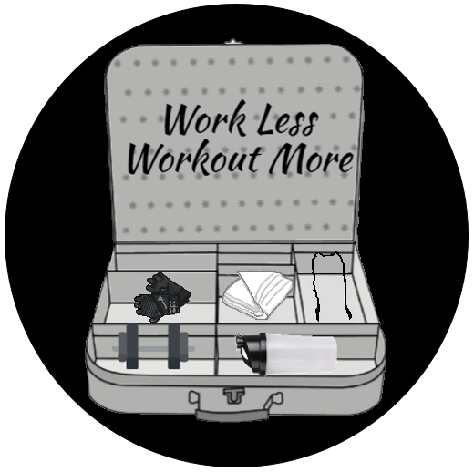

Figure 1: Project's Logo

Source: DH046 (2016)

# **2 Model case for adaptation: Uber**

Our group has chosen Uber as our model case in achieving a healthier lifestyle for working adults. Uber has achieved flourishing business in the taxi industry through the use of apps, increasing accessibility and attracting consumers. From interviews and online research conducted, the use of Uber's application as its main means to access its service brings about an aspect of convenience to its consumer's lives. By increasing convenience, we will be able to get more adults to exercise.

## **2.1 Characteristics of Model Case**

**Characteristic 1 *(C1)*: Convenience**

Figure 2: Advantages of Uber

Source: DH046 (2016)

Reports (Business Insider, 2015) have claimed that the main source of Uber’s flourishing business is due to its application. Our survey (DH046, 2016) (Refer to Figure 2) shows that 50% of respondents agree that the app brings about convenience when hailing for drivers as compared to the traditional method of hailing for taxis. Respondents agree that the app brings about convenience when hailing for rides as compared to the traditional method of hailing for taxis.

**Characteristic 2 *(C2)*: Relatively Low Prices**

Consumers are appealed by the relatively low pricing compared to taxi fares. Forty percent of our respondents claimed that they prefer Uber to a taxi due to the pricing differences, allowing them to make a decision based on their budget (Refer to Figure 2, Page 3). The Uber app provides an approximation of how much the journey will cost, unlike other taxi providers, allowing riders to decide if the ride is within their budget.

**Characteristic 3 *(C3)*: Transparency of Information**

Users are able to view the cost of the ride before booking a ride. The location of the assigned driver can also be tracked via the app, which lets users estimate the waiting time left. Half of our respondents liked the fact that the app was transparent in giving out information, allowing the users to feel reassured of getting a safe ride. Information on the assigned driver is made available to the passenger, such as their phone number and car plate number, ensuring the safety of the passenger.

## **2.2 Impacts of model case**

The characteristics of the model case creates both positive and negative impacts on different stakeholders.

**Positive Impact 1 *(P1)*: Increasing loyal user base**

The ability to see nearby Uber drivers via the Uber mobile app has brought convenience to users, such as working adults, compared to traditional way of flagging taxis without getting an estimate of arrival time. Working adults, who require transport to their workplaces daily, will continue to use the app as it is quick and easy, expanding Uber's loyal user base and increasing their bigger profits (Due to C1, Section 2.1, Page 3)

**Positive Impact 2 *(P2)*: Uber earn huge profits**

Due to the convenience that the Uber app brings and the relatively lower cost of Uber, Uber will be able to gain a huge base of needs of commuters and drivers. The usage of Uber will increase, allowing them to make huge profits.(Due to C1 and C2, Section 2.1, Page 3 and 4)

**Negative Impact 1 *(N1)*: Lack of security and reliability**

Uber may be misused for undesired purposes due to uncertainties like the lack of information of drivers and passengers. Drivers can potentially sign up with fake names to prevent being identified subsequently and drive passengers to deserted areas and commit a crime like robbing them (Nuzzi, 2014). Similarly, passengers can also potentially do likewise by having a deserted area as a destination. (Due to C2, Section 2.1, Page 4)

## **2.3 Lessons learnt**

From the characteristics inferred that make Uber good, we can learn how to adapt the characteristics to negate the negative impacts and improve on the positive impacts.

***Lesson Learnt 1 (LL1): Smartphone application***

Do design an innovative smartphone application to attract more users and provide them easier accessibility and more convenience.(Achieve P1, Section 2.2, Page 5)

***Lesson Learnt 2 (LL2): Needs of people***

Do cater to specific needs of different groups of people. (Achieve P2, Section 2.2, Page 5)

***Lesson Learnt 3 (LL3): Privacy***

Avoid revealing excessive information of users openly as to avoid bringing danger. Implement security measures to access private information only when required. (Minimise N1, Section 2.2, Page 5)

# **3 Target case: Working adults of achieving healthy exercise habits**

Our target group is the working adults as there has been an increasing number of working adults in Singapore leading unhealthy lifestyles and have been gaining weight with more years of work (Jobscentral, 2015).

## **3.1 Characteristics of working adults**

This section will explore the characteristics of working adults in order for us to adapt our proposal to cater to their needs.

***Characteristic 1 (TC1): Busy time schedules***

Most working adults who are physically inactive cited that they had no time for exercise due to work and family commitments (Health Promotion Board, 2013). Singapore has an average of 2389.4 hours in 2014, making it first in terms of longest working hours in the world (Straits Times, 2015).

***Characteristic 2 (TC2): Lack of motivation to exercise, would rather spend time on pursuing other things***

Our survey findings show that only 5 out of 40 (12.5%) of our working adults respondents would spend their free time exercising (DH046, 2016) (Refer to Figure 3). This suggests that they do not understand the importance of healthy exercising habits and make exercise as a main priority.

Figure 3: Activities working adults do during their free time

Source: DH046 (2016)

## **3.2 Current methods used to achieve healthy lifestyles of working adults and their limitations**

By analysing the current methods used, we are able to assess and eliminate the problems faced in tackling the problem.

|  |  |  |
| --- | --- | --- |
| **Method** | **How it works** | **Limitations** |
| **M1:**  National Steps Challenge | A physical activity initiative, targeted at Singaporeans above 18 years old, by Health Promotion Board. Its first season ended in July 2016, while the second season is to start in October 2016. Works by a point system where points, which are used to earn sure-win vouchers and enter lucky draws, are awarded to participants based on number of steps taken which is tracked by a HPB steps tracker, issued to each participant upon sign-up. | Participants can simply shake the tracker or attach it to a moving object to clock the number of steps, without actually having to move around. |
| **M2:**  One Million Kg Challenge | A nation-wide weight management programme from 2014 to 2016 by Health Promotion Board, aimed to get Singaporeans to collectively lose one million kilogrammes and promote healthy lifestyles and exercising. It is open to those aged 18 to 64 with a BMI of between 18.5 and 37.4. A participant can track his progress in the challenge, participate in level activities to earn rewards, scan QR codes to register his participation in events and redeem rewards, inclusive of holiday packages and a car. | Without the tangible rewards, people might not be motivated to exercise and lose weight. |

# **4 Proposal**

To cater to the needs of working adults, we have come up with a few proposals.

|  |  |
| --- | --- |
| Proposal | Target Agent |
| Install gym cubicles near companies  (Refer to Section 4.1 page 11-17) | * Trilogy Technologies Private Limited (vending machine company) * Anytime Fitness (gym equipment company) |
| Fit4Fitness Application  (Refer to Section 4.2 page 18-26) | * Rainmakers Lab * Community Centres |
| Step Up  (Refer to Section 4.3.1 page 28) | * Health Promotion Board * RedMI |
| The Good In Fun (Refer to Section 4.3.2 page 29) | * Members of public as facilitators |
| Cycle For Power (Refer to Section 4.3.3 page 30-32) | * NordicTrack (exercise bike company) |

## **4.1 Cubicle Gyms**

**Install gym cubicles near companies**

To help working adults who have trouble finding a convenient place or time to exercise, gym cubicles are to be implemented (Applying LL2, Section 2.3, Page 6). Now, working adults can gym conveniently and privately (Applying LL3, Section 2.3, Page 6). ‘Anytime Fitness’ company is to provide us with relevant gym equipment and vending machine companies like Trilogy Technologies Private Limited is to provide us with cubicles.

Figure 4:

Source: DH046 (2016)

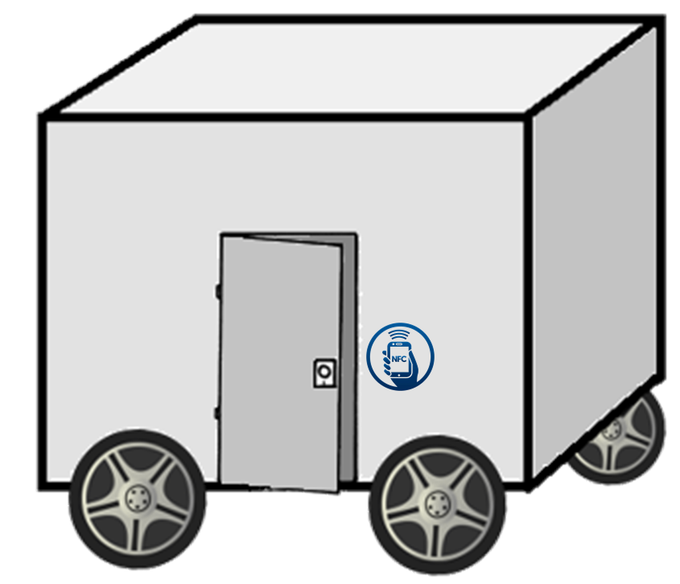

Characteristic 1

Figure 5: Exterior of a gym cubicle

Source: DH046 (2016)

Bright colour:

Catch people’s attention

Catch line:

Using pun (ride and right) to allow people to remember it.

Links to social platforms for marketing

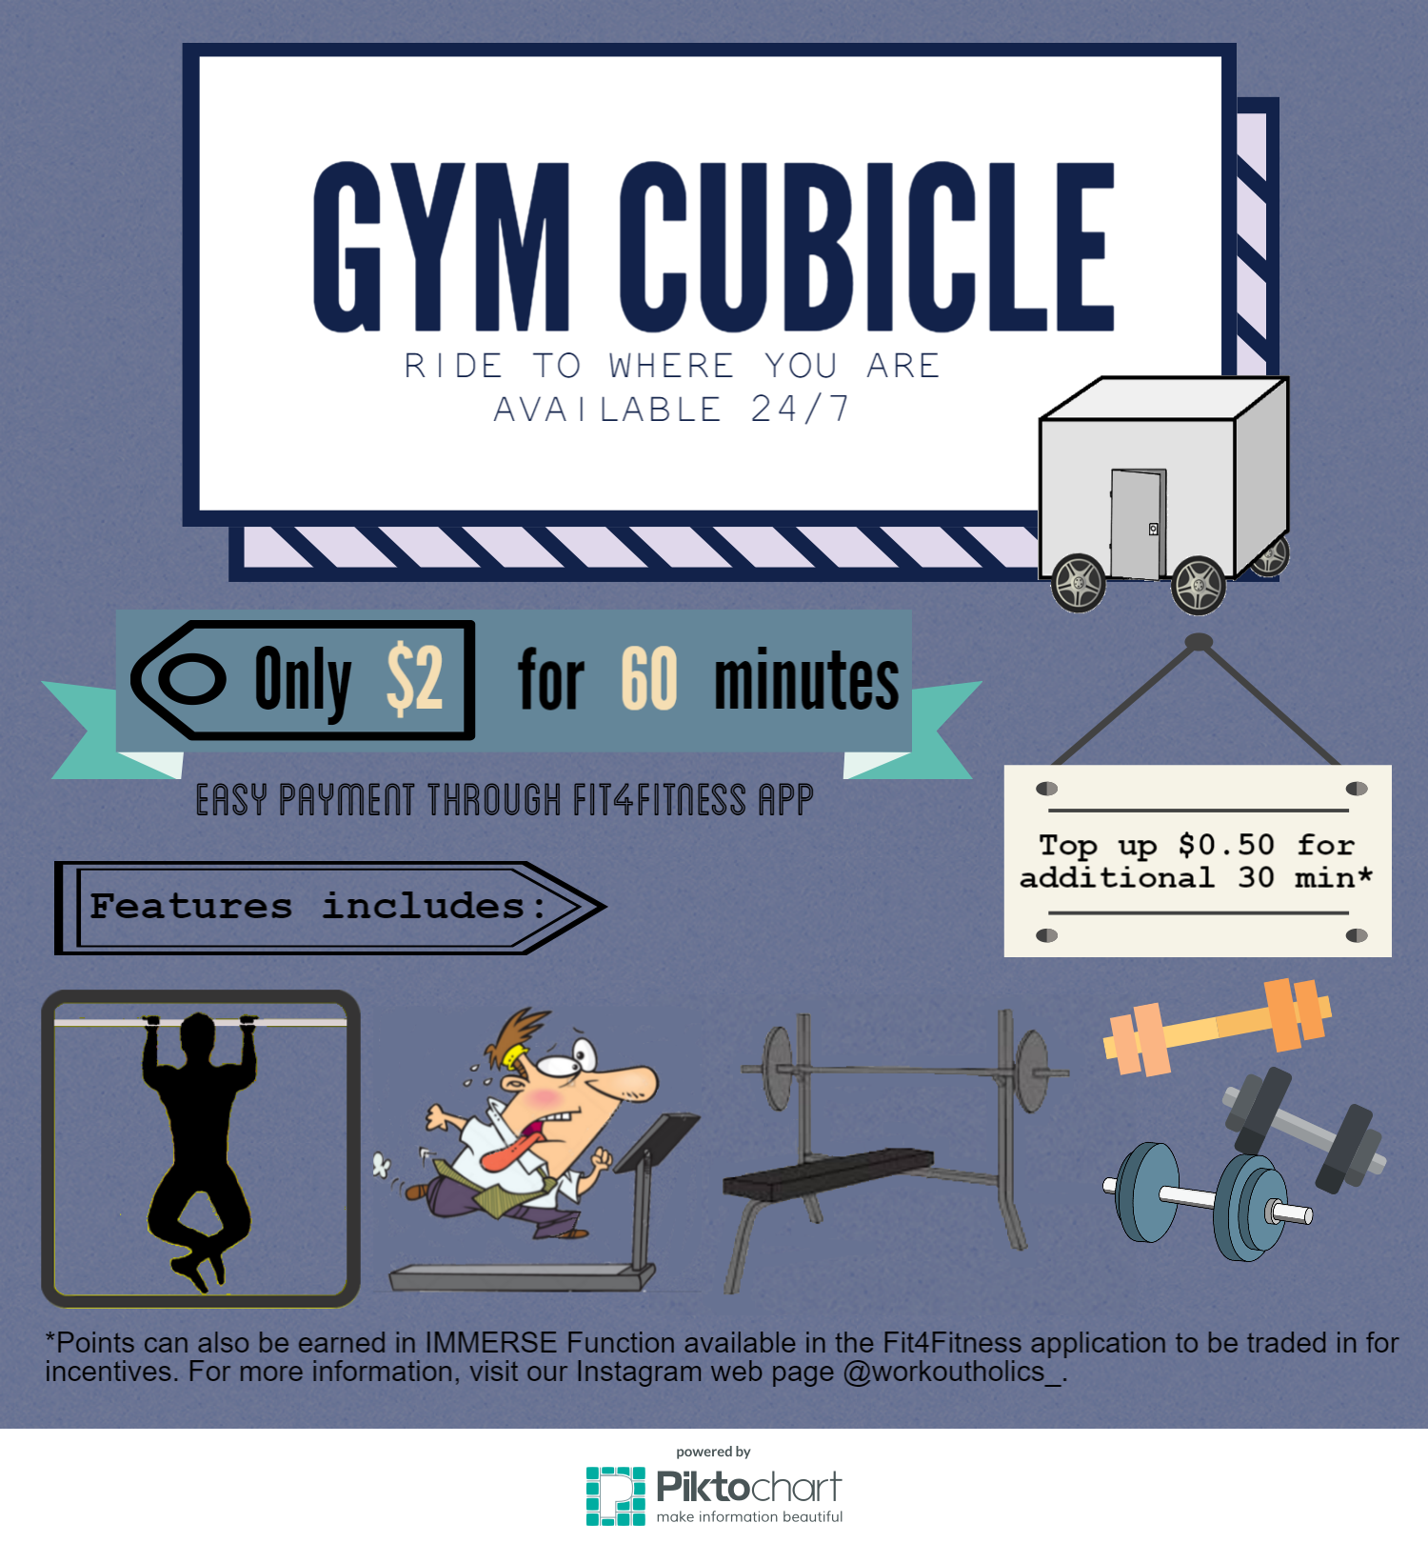

Characteristic 2

Asterisk: Bringing links to IMMERSE function

Links to social platforms for marketing

Bright colour:

To catch people’s attention

Catch line: Using pun (ride and right) to allow people to remember it

Figure 6: Poster advertising the gym cubicle

Source: DH046 (2016)

**Characteristics of gym cubicles:**

(v) Speakers and fans

(i) Gym equipment

C:\Users\Teo\AppData\Local\Microsoft\Windows\INetCacheContent.Word\oie_transparent (7).png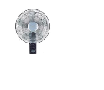 C:\Users\Teo\AppData\Local\Microsoft\Windows\INetCacheContent.Word\oie_transparent (2).pngC:\Users\Teo\AppData\Local\Microsoft\Windows\INetCacheContent.Word\oie_transparent (3).png

(vii) Security cameras

(ii) Machine

(vi) Light refreshments

(iv) Dance pad

(iii) Large LED panels

Figure 7: Layout of a gym cubicle

Source: DH046 (2016) 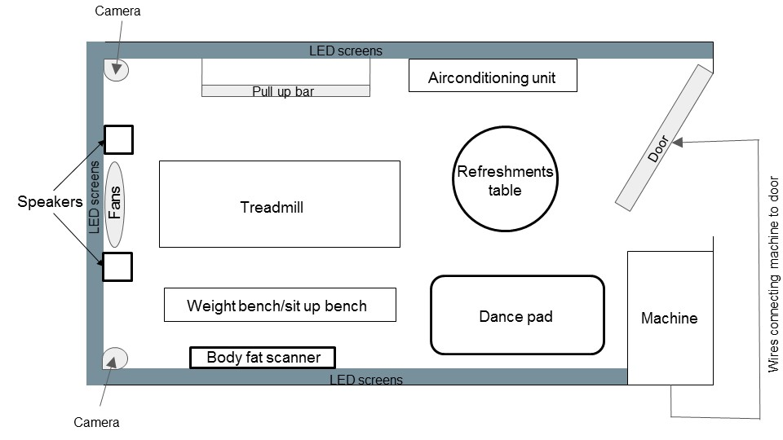Figure 7: Bird’s eye view of a gym cubicle

Source: DH046 (2016)

|  |  |
| --- | --- |
| Facilities | Function |
| (i) Gym equipment - treadmill, bench press pull ups | Allow people to do various exercises. |
| (ii) Free Weight Machine | According to recommendations from the ‘Fit4Fitness’ App (Refer to Section 4.2, Page 16), individuals can rent fitness equipment like inflatable dumbbells and gym balls (Applying LL1, Section 2.3, Page 7) (Refer to Figure 4, Section 4.1, Page 14). |
| (iii) Large LED panels | Walls of gym cubicles can transform into different themes like beach, park or sports hall by selecting them through ‘Fit4Fitness’ app (Refer to Section 4.2, Page 16). |
| (iv) Dance Pad | Wide variety of exercises available for selection (similar to Dance Evolution in arcades) and beginners can learn the moves by following the actions of a virtual 3D instructor on the screen step by step on a dance pad. |
| (v) Speakers and fans | Play sounds like waves crashing and control the amount of wind to suit the surroundings. Users may also choose to wear virtual reality headsets which are connected via Bluetooth with their phone, provided in the gym to give them a more realistic surrounding. |
| (vi) Light refreshments | Salads, energy drinks and protein food provided during lunch hours (sponsored by 100PLUS) so that they do not have to worry about their lunch after their workout |
| (vii) Security camera | Identify those who damage the gym equipment. |

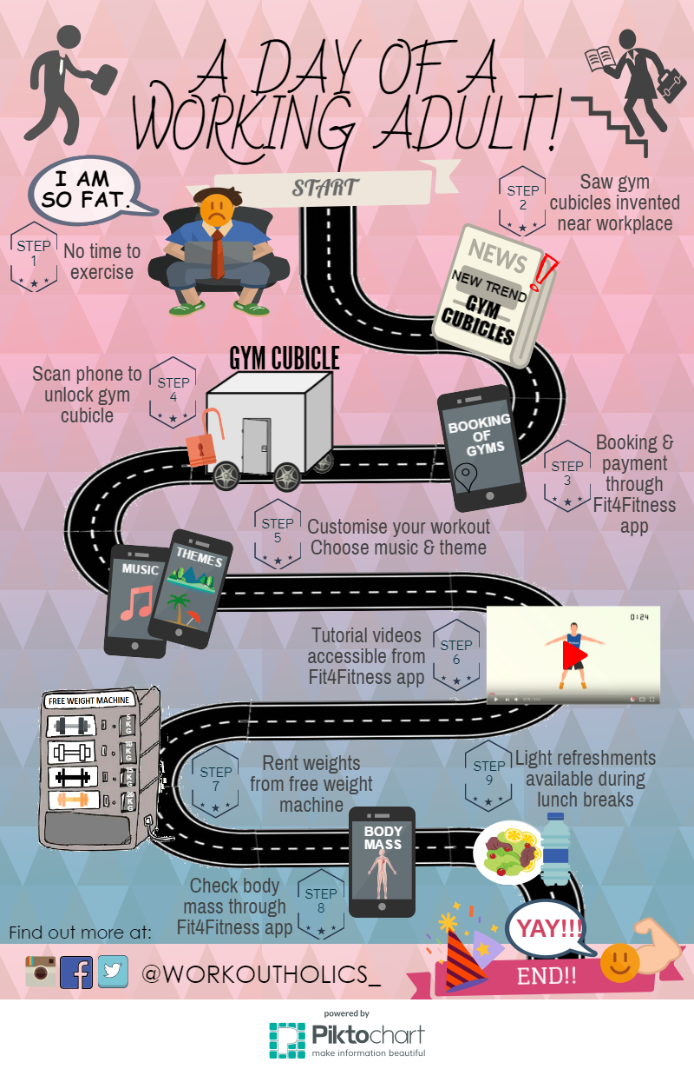

Working adult climbing stairs:

Shows that working adults are able to find time to exercise, motivating working adults to exercise in their free time.

Characteristic 3

Links to social platforms for marketing

Meandering road:

Shows the process of how an experience at a gym cubicle is like

Vibrant background colours:

Attract attention

Figure 8: Experience of a working adult at gym cubicle

Source: DH046 (2016)

|  |  |
| --- | --- |
| Characteristic | Function |
| 1. Driverless  (Refer to Section 4.1, Page 10) | Driverless gym cubicles will drive to the designated address stated by the user after they have paid. |
| 2. Available 24/7 (Refer to Section 4.1, Page 11) | Working adults are often working during the day. A 24-hour gym would provide for those who have trouble finding a convenient place or time to exercise. |
| 3. Scan phone to unlock gym cubicle  (Refer to Section 4.1, Page 15) | Scan phone on Near Field Communication (NFC) reader to unlock gym cubicle, to prevent others from using it. |

## **4.2 Fit4Fitness Application**

Figure 9: Opinion on customizable fitness application

Source: DH046 (2016)

Also, to help working adults increase the amount of time that they exercise, we have come up with the idea of a smartphone application (Applying LL2, Section 2.3, Page 7), to be realised by app designer companies such as Rainmaker Labs, which can also complement the usage of the cubicle gyms. From our survey conducted (DH046, 2016) (Refer to Figure 7), The application, which is aimed at smartphone dependent working adults, grants users convenience and waste less time when going to the gym.

**Features of the app:**

1. **Locations and availability of gym cubicles**

Inspired from Google Maps where it depicts maps of facilities to provide users with directions to their destinations (Refer to Figure 10, Section 4.1, Page 14), this increase in accessibility encourages people to travel to our gym cubicles. The availability of the gym cubicles is also indicated on the app, as well as the option of paying and booking beforehand (Refer to Figure 11, Section 4.1, Page 14) line payment receipt uses the phone's Near Field Communication to unlock the gym door when the phone is brought near to the scanner.

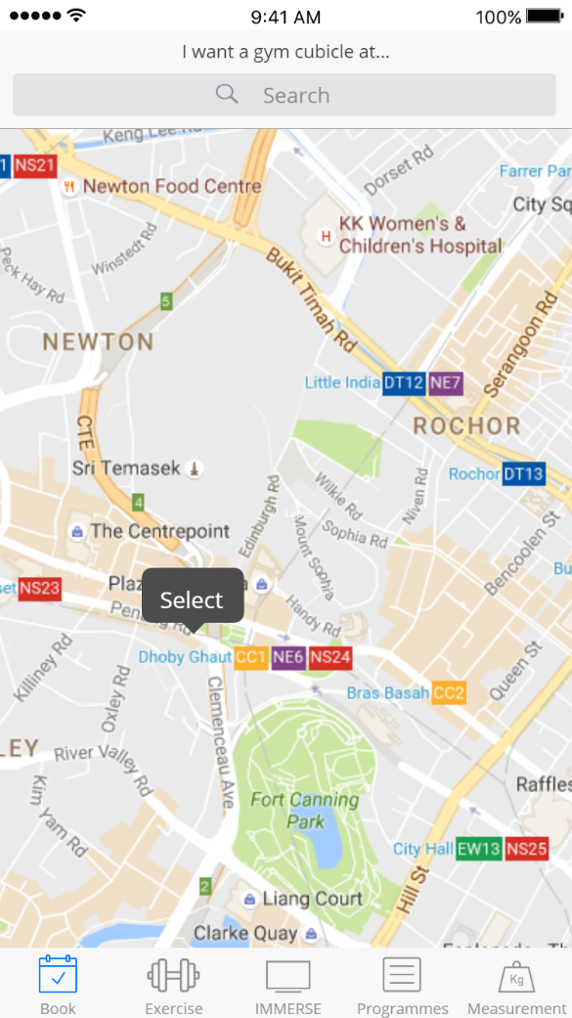 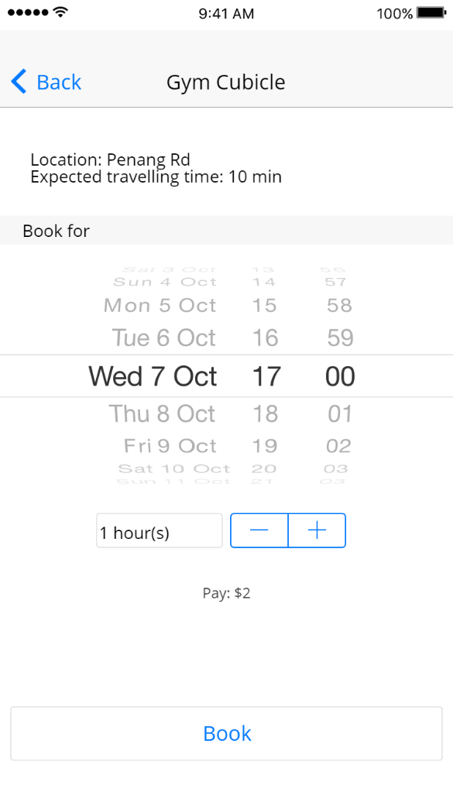  
Figure 10: Location of cubicle gyms in app Figure 11: Booking screen for gym cubicle

Source: DH046 (2016) Source: DH046 (2016)

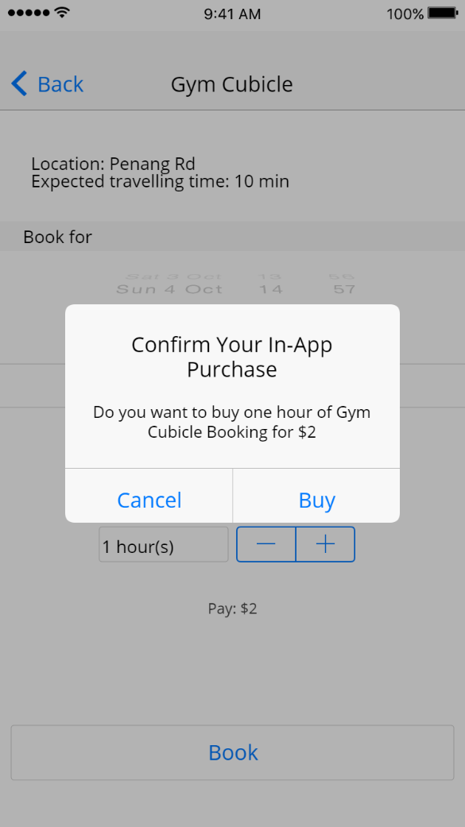 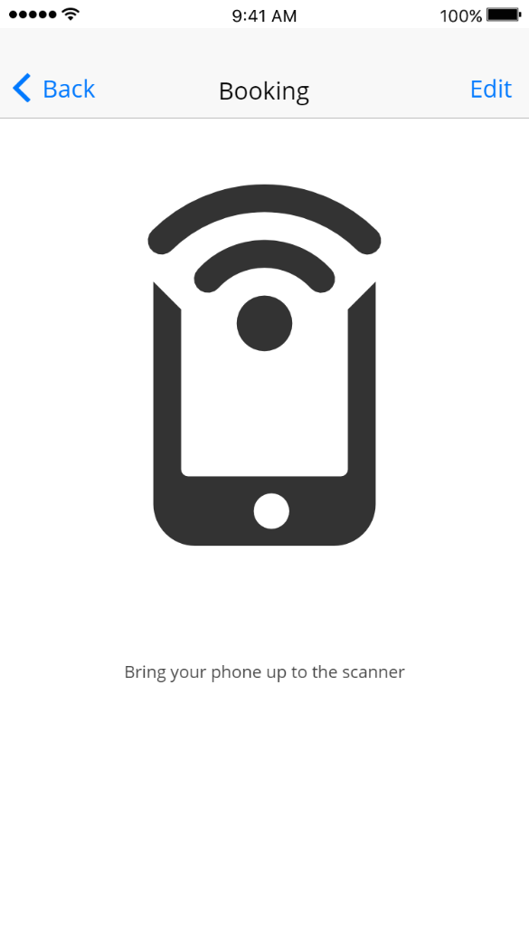

Figure 12: Payment for gym cubicle Figure 13: After payment screen

Source: DH046 (2016) Source: DH046 (2016)

1. **Fat content and muscle mass analysis**

Users will get to weigh themselves using a body fat scanner and input the data into the app, which will then display the muscles and fats composition in the user’s body and motivates them to obtain their ideal muscles and fats proportion (Refer to Figure 14, Section 4.1, Page 14)

These analyses will be inputted in the app under ‘Health’ and each health improvement made by the users daily will be recorded in a calendar for the respective days to allow users to check on their progress and further motivate them. The app will then scan through a list of the pre-customized workouts and choose one that best fits the user's body type which is determined from part with the highest fat concentration based on the body fat scan.

Users can choose to deactivate this function if they wish to focus on strengthening a specific part of their body instead.

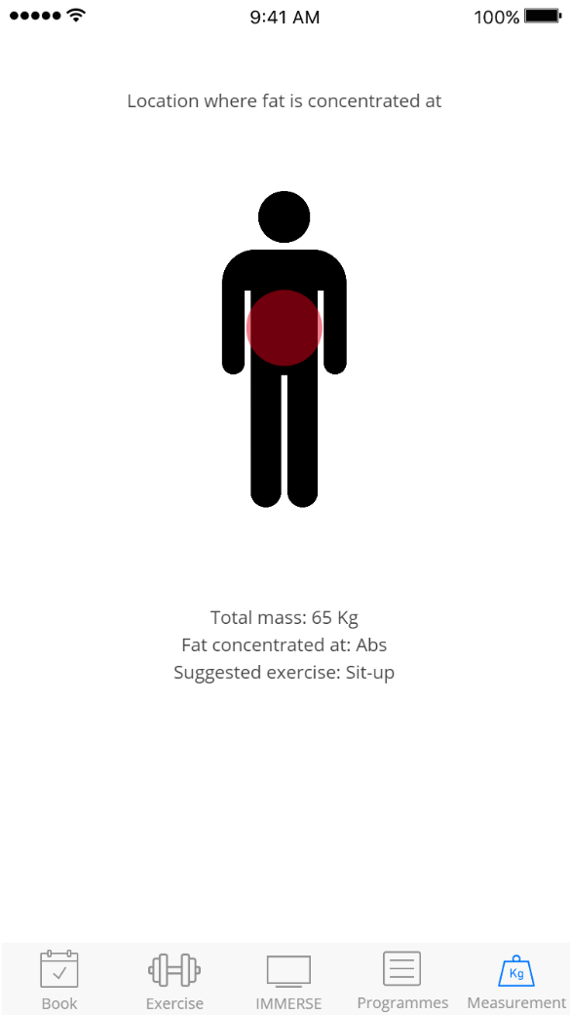

Figure 14: Fat analysis

Source: DH046 (2016)

1. **Variety of exercises and workout routine for specific muscle groups**

Should users want to focus on strengthening a specific part of their body (Refer to Figure 15, Section 4.1, Page 14) relevant workouts will be recommended (Refer to Figure 16, Section 4.1, Page 14). A list of recommended equipment available at the gym cubicles will also be provided for users keen on exercising at the gym cubicles.

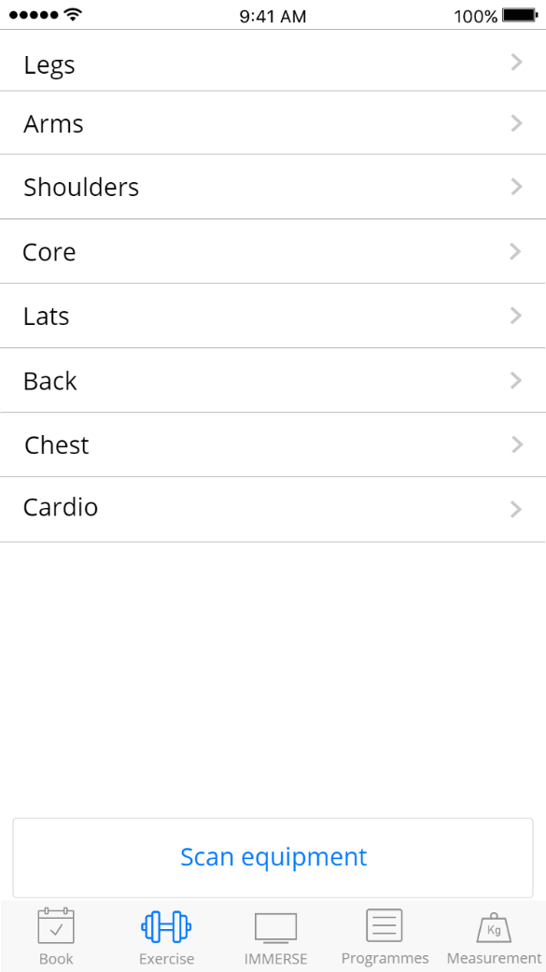 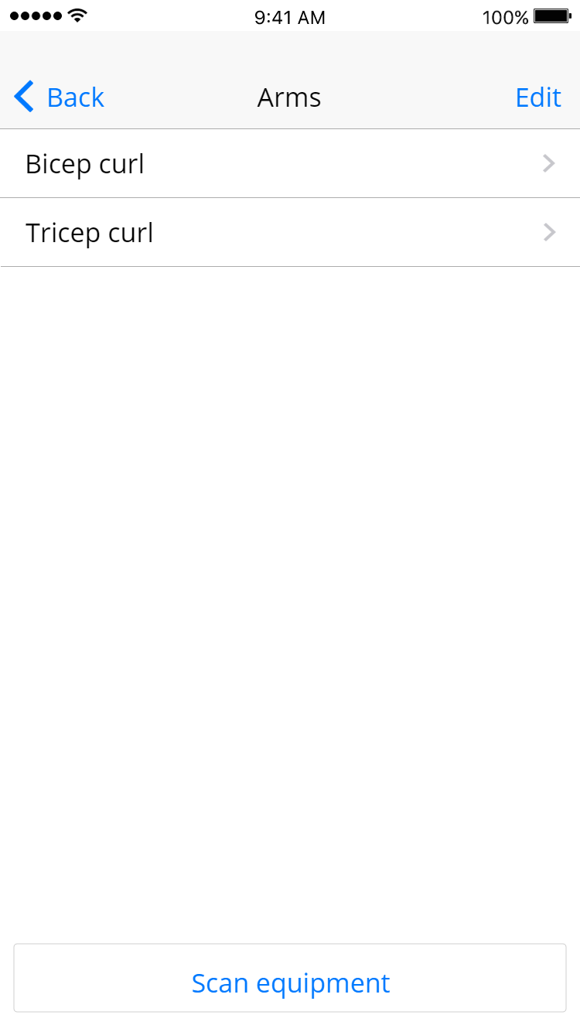

Figure 16: List of workouts specific to body part

Source: DH046 (2016)

Figure 15: List of body parts for exercise

Source: DH046 (2016)

1. **Workout tutorial videos and instructions available**

There will be tutorial videos and instructions of the workouts (Refer to Figure 17, Section 4.1, Page 14) to serve as a guideline for users keen on learning how to exercise effectively.

The app also has an inbuilt recognition feature making use of the phone camera, and allows the app to recognize the equipment being used and is able to filter through the different pre-downloaded videos to find those that make use of the equipment. These videos are accessible even without an internet connection.

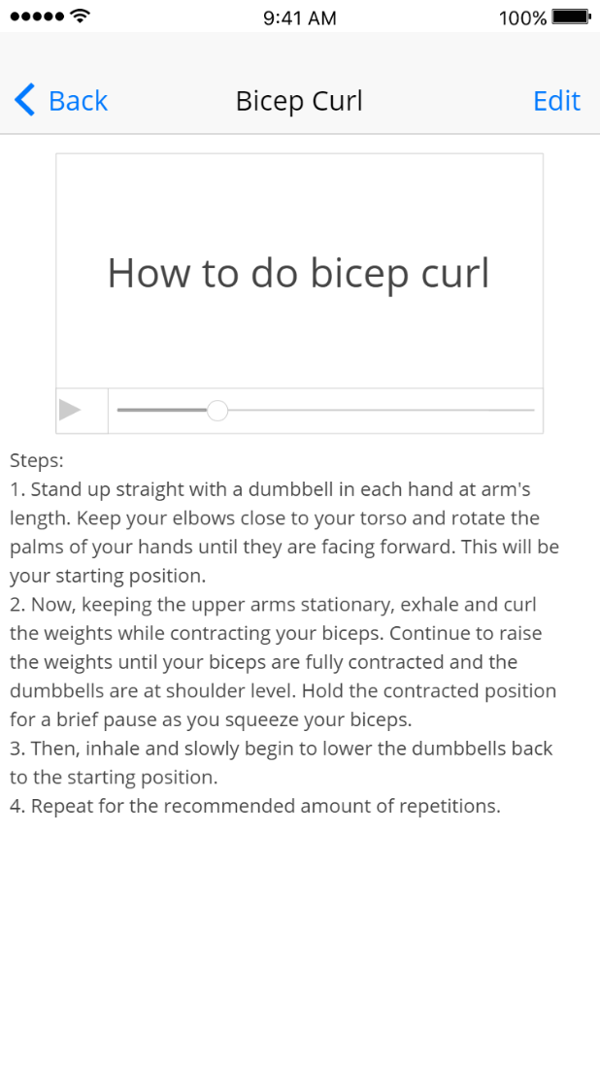

Figure 17: Instructions for workout

Source: DH046 (2016)

1. **Programmes offered at fitness and community centres**

It shows the timeslots of programmes (Refer to Figure 19, Section 4.1, Page 14), such as yoga and tai chi, available at the respective community centres (Refer to Figure 18, Section 4.1, Page 14) since they are highly accessibility due to their availability in every neighbourhood. Sound notifications via phones will be received by individuals when there are available timeslots of various sessions near their location which they can register themselves for based on their preferences.

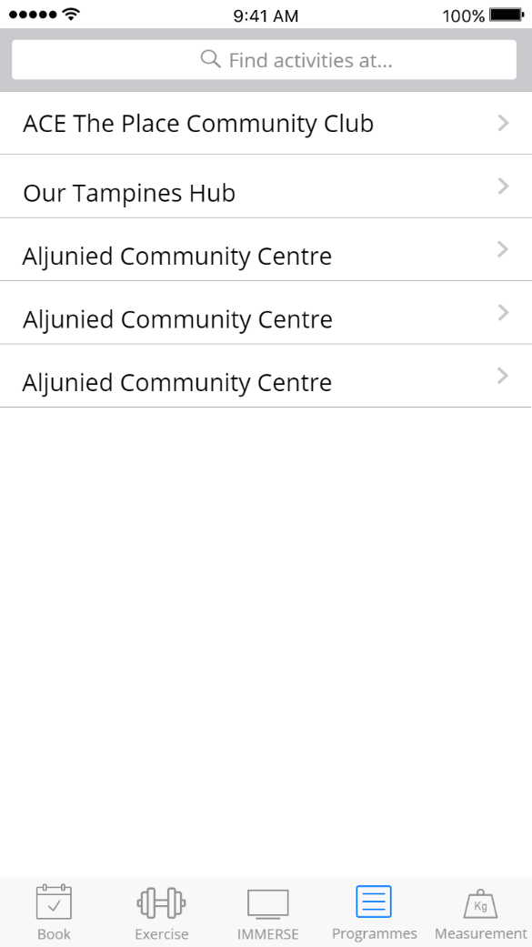

Figure 18: List of community centres

Source: DH046 (2016)

 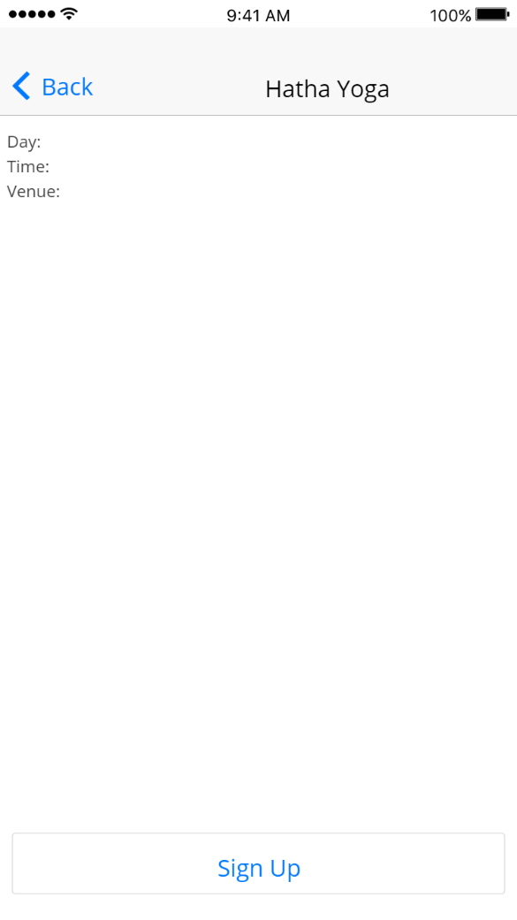

Figure 19: List of activities in community centres

Source: DH046 (2016)

Figure 20: Details of activity

Source: DH046 (2016)

1. **IMMERSE function**

There will be different settings and scenery to choose from. By connecting the app to a screen in the gym cubicle, users can experience an immersive scenario based environment, with settings of a marathon or a zombie apocalypse (Refer to Figure 21, Section 4.1, Page 14). They can earn points by running, and the sounds and visuals of zombie chasing them gives them more motivation. For weightlifting, users can select a weightlifting competition scene, earning points by lifting heavier weights which can be used to level up the user’s in-game character or buy power ups. At the end of the work out, they can also see their ranking based on the people who have played the same game. The ranking system allows them to build motivation and train harder to beat their previous high score, or to get a higher place on the leaderboards. Free minutes can be redeemed from the points earned for the next time they visit the gym cubicle.

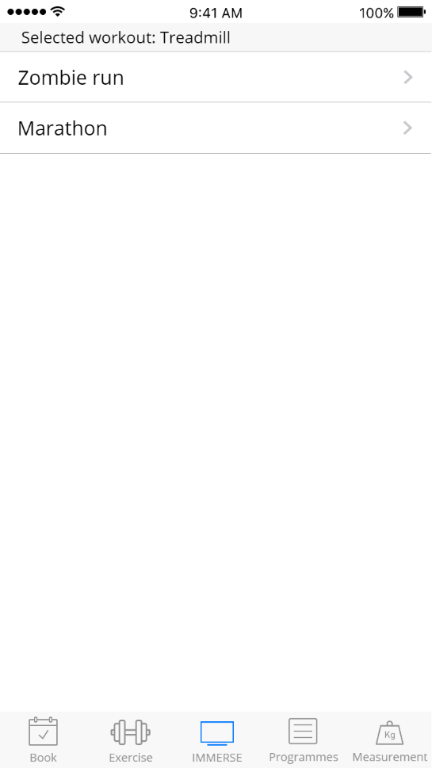

Figure 21: IMMERSE function

Source: DH046 (2016)

## **4.3 Events or programmes by companies**

Health Promotion Board can approach companies to plan events where employees can bond and exercise at the same time. They can make such outings for cohesion instead of making it as an exercise routine every month. This way, employees will look forward to each cohesion rather than to dread working out.

Figure

Source: DH046 (2016)

### **4.3.1 Step Up**

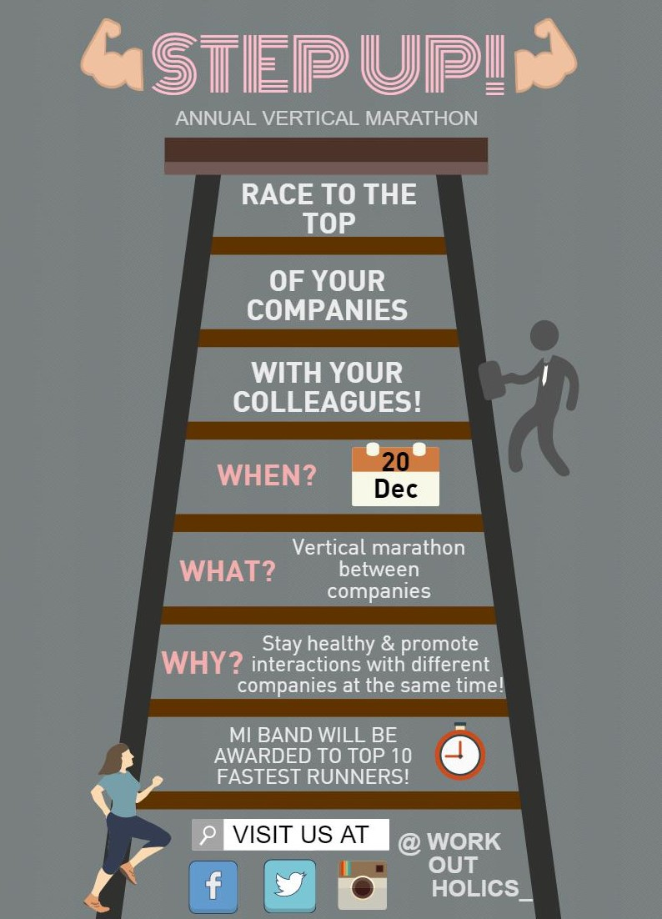

Pink title:

Eye-catching colour to attract attention

Muscles emojis: Motivate workers to join the event to be fit

Capital letters:

Capture attention

Working adult running:

Promoting good exercising habits within working adults

Vertical ladder:

Symbolising vertical marathon

Links to social platforms for marketing

Figure 22: Outlines of the event "Step Up"

Source: DH046 (2016)

### **4.3.2 The Good in Fun (TGIF)**

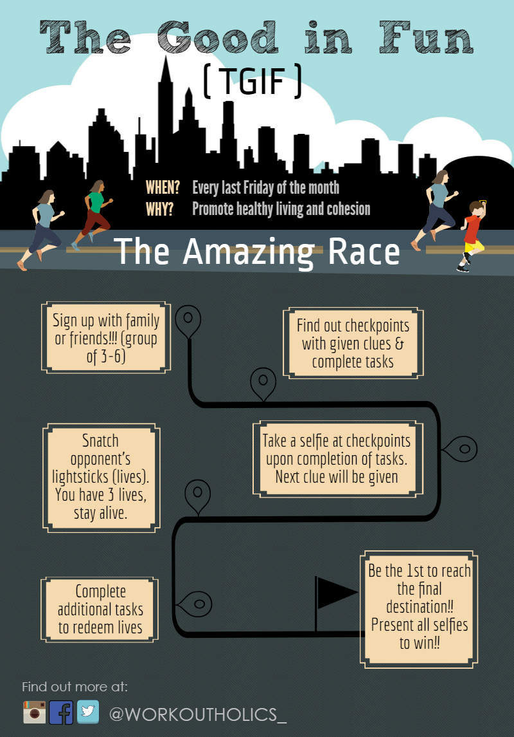

Acronyms:

For public to remember easily

Road journey:

Explains how the event works

Road journey:

Explains how the event works

Checkpoint:

Different stages of the race

Links to social platforms for marketing

Flag:

Signifies final destination

Font:

Fun Font to attract children (targeted at families)

City silhouette:

Signifies that it will be held all around the city

Figure 23: Outlines of the event "The Good In Fun"

Source: DH046 (2016)

### **4.3.3 Cycle for power**

Details of initiative

Formula: People can relate to universally known formula

Large white font: Grab attention

Lightning bolt: represents energy

Links to social platforms for marketing

Bicycle: Lets people know the form of exercise

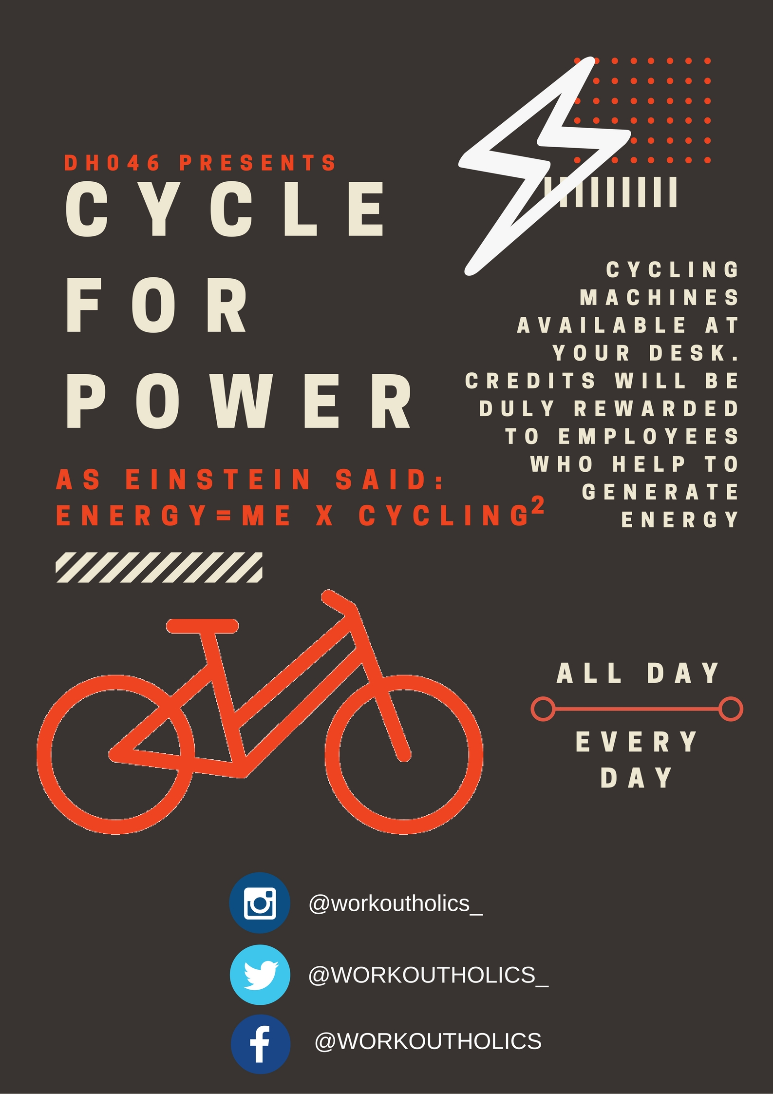

Figure 24: Outlines of the programme "Cycle for Power"

Source: DH046 (2016)

Companies can set up a reward system to incentivise employees (Counter TC2, Section 3.1, Page 8). These credits could be used to enjoy various benefits (Refer to Figure 25) by inserting the card into a terminal. These will allow employees to be energised in work and also save electricity for the company. Furthermore, extra effort to travel is not required for employees to exercise. Apart from the incentives that they ripped from cycling, they are unknowingly staying healthy.

|  |  |
| --- | --- |
| Details of Cycle for Power | |
| Reward system | * Incentivise employees by giving them rewards (Counter TC2, Section 3.1, Page 8). * Place cycling machines at each desk to allow employees to exercise while doing their work simultaneously (Counter TC2, Section 3.1, Page 8). |
| Credits | * For every 1 km cycled, 1 credit will be earned. * Credits are automatically added into their office pass when they insert the card into the machine * Exchange for various benefits (Refer to Figure 25, Page 33) |

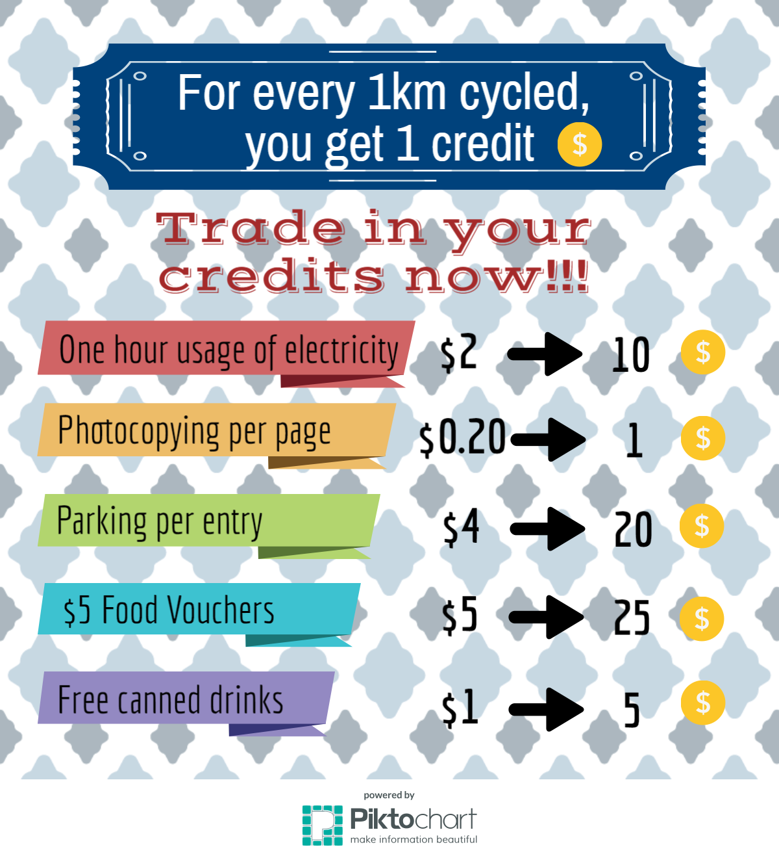

Figure 25: Credits system

Source: DH046 (2016)

# **5 Evaluation of proposal**

There are some limitations to our proposals but we have come up with solutions to counter these problems.

|  |  |  |
| --- | --- | --- |
| Proposal | Limitations | Solutions |
| Gym cubicles | **L1:** Gym users may damage the equipment during their exercise, preventing other users from enjoying the facilities. | **S1:** Gym users are to scan their fingerprints or identification cards in order to activate and use the equipment. This allows users who misuse the equipment to be easily identified and fined. If the equipment is spoiled, reports and compensation will be sent through the app which is to be used as a complement to the cubicle. ‘Anytime Fitness’ company to conduct regular checks on the equipment in the gym cubicles and replace them once it is worn out to ensure that the damage is not caused by normal wear and tear. |
| Cycle for Power | **L2:** Employees may think that it is not worth cycling so much just for that particular benefit hence they might just pay the original price instead of exercising. | **S2:** Companies can raise the price or decrease the number of credits required to enjoy the benefits so prevent employees from doing so. |

# **6 Conclusion**

Upon further research on the characteristics of our model case, Uber, that make them successful, we have derived guidelines on how to help our target group, the working adults. With the implementation of our proposals, we seek to provide means of exercising and motivate the working adults, ultimately achieving our aim of getting them to exercise 2-3 days weekly in Singapore.

# **7 Bibliography**

Websites

1. Straits Times Review. (2015). Singapore maintains its no 1 ranking in longest working hours in the world. [On-Line]. Available: <http://statestimesreview.com/2015/06/16/singapore-maintains-its-no-1-ranking-in-longest-working-hours-in-the-world/>
2. Health Promotion Board. (2013). Physical Activity. [On-Line]. Available: <http://www.hpb.gov.sg/HOPPortal/health-article/HPBSUEXTAPP1_4022027>
3. AWorkoutRoutine.com. (2014). How Long Should My Workout Be? 30, 45, 60 Minutes? Over An Hour? [On-Line]. Available: <http://www.aworkoutroutine.com/how-long-should-my-workout-be/>
4. [Joel Libava](http://smallbiztrends.com/author/libava). (2009). 24-Hour Fitness Franchises Still Growing; Is There Still Room For More? [On-Line]. Available: <http://smallbiztrends.com/2009/02/24-hour-fitness-franchises-still-growing-is-there-still-room-for-more.html>
5. Olivia Nuzzi. (2014). Uber’s Biggest Problem Isn’t Surge Pricing. What If It’s Sexual Harassment by Drivers?. [On-Line]. Available: <http://www.thedailybeast.com/articles/2014/03/28/uber-s-biggest-problem-isn-t-surge-pricing-what-if-it-s-sexual-harassment-by-drivers.html>
6. Jobscentral. (2014). Survey Results: Singapore Workers Reveal Their Working Weight Woes, in JobsCentral Survey. [On-Line]. Available: <http://community.jobscentral.com.sg/articles/survey-results-singapore-workers-reveal-their-working-weight-woes-jobscentral-survey>
7. TODAY Newspaper. (2014). One Million Kg Challenge launched to get Singaporeans to keep fit. [On-Line]. Available: <http://www.todayonline.com/singapore/one-million-kg-challenge-launched-get-singaporeans-keep-fit>
8. Channel NewsAsia. (2015). Life as a Uber driver: A fast road to easy money? [On-Line]. Available: <http://www.channelnewsasia.com/news/singapore/life-as-an-uber-driver-a/1979836.html>
9. Natasha Lomas. (2015). Let's Talk About Uber, Congestion And Urban Air Quality. [On-Line]. Available: <https://techcrunch.com/2015/08/26/uber-london-impact/>
10. Business Insider. (2015). The secret to Uber’s success: Be everywhere all the time. [On-Line]. Available: [http://www.businessinsider.sg/uber-apps-are-everywhere-2015-12/?r=US&IR=T#ybosRD3WVoa0XlJw.97](http://www.businessinsider.sg/uber-apps-are-everywhere-2015-12/?r=US&IR=T)
11. Adrian Lim. (2016). Fare cuts by Uber, Grab will hurt sector: Taxi body. [On-Line]. Available: <http://www.straitstimes.com/singapore/fare-cuts-by-uber-grab-will-hurt-sector-taxi-body>
12. Christina Merhar. (2015). Want Increased Productivity? Focus on Healthy Employees.[On-Line]. Available: <http://www.zanebenefits.com/blog/increased-productivity-and-healthy-employees>
13. Centers for Disease Control and Prevention. (2015). How much physical activity do adults need? [On-Line]. Available: <http://www.cdc.gov/physicalactivity/basics/adults/>
14. Rainmaker Labs. (2016). Mobile App Development. [On-Line]. Available: <http://rainmaker-labs.com/mobile-apps-development-singapore/>
15. Erin Brodwin. (2016). An exercise scientist reveals the fastest, most significant way to lose weight with minimal effort. [On-Line]. Available: [http://www.businessinsider.sg/how-to-lose-weight-according-to-an-exercise-scientist-2016-1/#.VzWulvl97IU#ruyydOk0wADcExL5.97](http://www.businessinsider.sg/how-to-lose-weight-according-to-an-exercise-scientist-2016-1/)
16. Chetan Narain. (2016). The New UberEATS App Is Here. [On-Line]. Available: <https://newsroom.uber.com/ubereats-app/>
17. Brian Fung. (2016). Uber's self-driving car: Prepare to be thrilled and bored at the same time. [On-Line]. Available: <http://www.chicagotribune.com/bluesky/technology/ct-pittsburgh-driverless-cars-20160914-story.html>